The landscapes of the Broads – an annotated field sketch

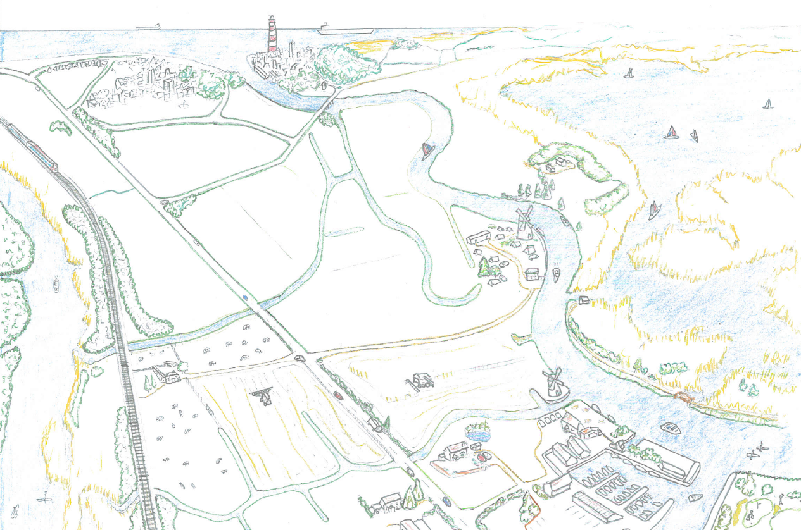

The landscapes of the Broads

The Broads National Park is a unique mosaic of different landscapes, lakes and rivers covering 303 square kilometres. Despite only being the size of 0.1% of the UK the park area boasts more than a quarter of its rarest wildlife. Iconic mills and historic landmarks nestle among miles of waterways, fen, woodland and footpaths while idyllic towns and villages dot the wide landscapes.
The info grid below provides an explanation of some of the landscapes and land uses of the Broads.
Broads | Towns & villages | Rivers | Wet Woodland
These are the 63 shallow man-made lakes. They began as pits dug for peat to provide fuel during medieval times and filled up with water over the centuries to become the boating playground we see today. | The waterways of the Broads connect several towns and numerous villages to each other. Historically the network of rivers would have been the main transport route between these settlements. | There are 7 major rivers in the Broads National Park with over 125 miles of navigable waterways. All of the rivers are connected, and it is possible to travel them all inland and without needing to access the sea. | The rarest of woodland in the UK with 3,000 hectares in the park. These waterlogged soils, trees and their shallow roots make the perfect habitat for amphibians, grass snakes, herons, otters, owls, bats and insects.
Q1. Which is the biggest Broad? | Q2. How many people live in the National Park? | Q3. Which is the longest river in the Broads? | Q4. What is the common name for wet woodland?
Answer: | Answer: | Answer: | Answer:
Water mills | Grazing marshes | Drainage dykes | Coastline
There are over 70 mills dotted across the Broads. Originally used to help drain the land of water and pump it elsewhere, the mills are now a tourist attraction to many and several are now open to the public to explore. | 40% of the Broads is wet grassland which is grazed by farmed livestock and supports a huge amount of wildlife. The Broads Authority work with farmers to sustain the ideal habitats for breeding waders & waterfowl | These straight water ditches are found across the Broads. Their purpose is to help the farmland areas to drain and move water away from the fields quickly. A network of 36 pumps lift the water from the dykes into the rivers. | The Broads includes a small 2.7km stretch of Norfolk coast. The beach at Horsey is backed by sand dunes and is one of the UK’s largest seal colonies. From Nov-Feb hundreds of seals and pups line the length of the shore.
Q5. Which is the last full-size working windmill in the Broads? | Q6. What is the most common type of livestock found on the marshes? | Q7. What is the name of the ditches that all the other dykes drain into? | Q8. What species of seal can be spotted on Horsey beach?
Answer: | Answer: | Answer: | Answer:
Fens | Tourism | Accommodation | Attractions
These are waterlogged areas of land dominated by reeds, rushes and sedge. The Broads boasts around 1,700 hectares of wildlife-rich fen the largest expanse in the UK. Reed and sedge have been harvested for centuries in the Broads. | Boating, cycling, canoeing, fishing, and wildlife-watching are just some of the ways to enjoy the Broads. Boats can be hired for day trips and overnight holidays allowing tourists to cruise the waterways at their own pace. | Whether staying for a holiday or just overnight there is a huge choice of places to stay in the Broads. These range from waterside campsites and B&B’s to luxury glamping and boutique hotels, you can even stay in a houseboat! | The Broads offers interest and adventure for all ages. Nearby attractions off the water include Pleasurewood Hills theme park, BeWILDerwood forest adventure and Roarr! Dinosaur park.
Q9. Which is the most common use for harvested reed and sedge? | Q10. How many people visit the Broads on average each year? | Q11. What type of unique building can you stay in on the River Bure? | Q12. What is the name of the ‘crocklebog’ who lives at BeWILDerwood?
Answer: | Answer: | Answer: | Answer:

Tasks:
- Gather the answers to the questions above and write these in the white boxes
- Use your answers and the text box above each to annotate the sketch of ‘the landscapes of the Broads’ – TIP: an annotation should include more detail than a simple label and point to the area which you are describing.

The landscapes of the Broads – Teachers notes

Answers to the information grid:

- Hickling
- 6,300 approx. (towns such as Great Yarmouth and Lowestoft although having the Broads running through and nearby to them are not technically part of the National Park, thew wider area has a population of more than 650,000 people)
- The River Bure (51km)
- Alder carr
- Herringfleet windmill
- Cows
- Soke (or sock) dykes
- Grey seal
- Thatching
- 7.5 million
- Windmill
- Mildred

Instructions for using these answers for a ‘globingo’ activity:

Hand out a information sheet to all students. Each student should also be given 1 small slip of paper on with 1 answer on. This answer should be numbered and the student can then enter this into the corresponding white box on their information sheet. Other members of the class will have been given different answers and will enter their answers into their relevant boxes.
Explain to students that they now have the correct answer to one of the questions and their classmates have the remaining answers which they will need to complete their sheets. Challenge the students to go around the class to collect the remaining answers from their classmates, the first student to receive them all wins! Give the rest of the class some time to collect their answers and then go through the answers using the PowerPoint presentation which will give images to support their understanding of each of the different land uses.

Instructions for completing the annotated sketch:

Hand out the annotated field sketch work sheets to students. Explain that field sketches are a useful way to display located information by adding detailed descriptions to the drawings. Refer students back to their (now complete) information pages. They can now use this information to help them annotate the field sketch which is provided.
Rather than copying the information, encourage the students to condense the summaries for each land use into less than 10 words. They should use a pencil and a ruler to draw an arrow to a particular land use on the sketch and then add their annotation besides this. Challenge students to use specific facts and figures in their annotations.

