The value of tourism to the Broads
The key data (2009-17)
 | 2009 | 2010 | 2011 | 2012 | 2013 | 2014 | 2015 | 2016 | 2017
Total visitor numbers (millions) | 6.48 | 6.36 | 6.60 | 6.63 | 6.58 | 6.83 | 6.54 | 6.56 | 6.82
Total tourism-related jobs | 3,526 | 3,482 | 3,597 | 3,644 | 3,701 | 3,773 | 3,569 | 3,559 | 3,680
Total tourist spending (£ millions) | 226 | 230 | 250 | 259 | 265 | 283 | 275 | 280 | 296

Tourism is hugely important to the Broads – measuring specifically just how important, can only be discovered by considering actual tourism data.
Every several years the Broads Authority analyse their data and produce a STEAM report. The latest report covers the period 2009-17. The data below is a selection of some of the key numbers from that report.

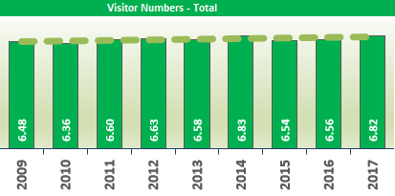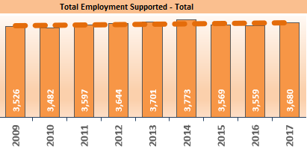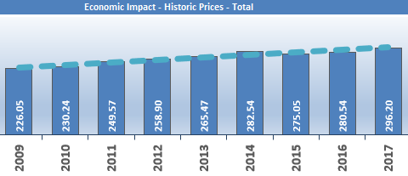
Analysing this data
How many million tourists visited in 2017? | What is the ‘trend’ in tourists over time? | What is the ‘mean’ number of tourist jobs | When was there a possible ‘anomaly’ in these results? | What was the ‘range’ in tourist spending 2009-17? | What is the ‘trend’ in spending over time?
What type of shops, services and facilities do you think are required to cater for all these people? |  | The Broads is home to approx. 6,300 people – how significant is tourism for providing jobs locally? |  | What do you think are the main things tourists spend their money on in the Broads?
The value of tourism to the Broads – Teachers notes

Answers to the information grid:

How many million tourists visited in 2017?  6.82 | What is the ‘trend’ in tourists over time?  Visitor numbers have steadily increased over this period | What is the ‘mean’ number of tourist jobs  3,615 | When was there a possible ‘anomaly’ in these results?  Possibly in 2014 as the jobs were slightly higher than the trend. | What was the ‘range’ in tourist spending 2009-17?  70 | What is the ‘trend’ in spending over time?  Tourist spending has increased significantly in this period
What type of shops, services and facilities do you think are required to cater for all these people?  Accommodation, restaurants & cafes, supermarkets, toilets, parking, cash machines, etc |  | The Broads is home to approx. 6,300 – how significant is tourism for providing jobs locally?  It is very significant, however, despite the fact that 3,615 jobs are in the tourist sector, these are not likely all to be taken by local people. Many will travel to the Broads to work. |  | What do you think are the main things tourists spend their money on in the Broads?  Accommodation is the highest cost for those staying overnight. For day trippers boat hire or cruise tickets are often the biggest cost.

Mapping boat data in the Broads using GIS
The following information is a summary of data gathered by the Broads Authority over 3 days in the summer of 2018:

Table of moving vessel numbers on the Broads rivers, 2018 |  |  | Total vessels | Passenger vessels | Motor cruisers | Sea-going cruisers | Day boats | Sailing boats | Rowing boats | Canoes / Kayaks | Paddle boards | Other
Latitude | Longitude | Recording site
52.7088 | 1.4093 | Wroxham | 2,330 | 79 | 696 | 10 | 1,449 | 23 | 10 | 52 | 2 | 9
52.7054 | 1.4614 | Horning | 1,729 | 32 | 1,019 | 13 | 581 | 26 | 29 | 23 | 0 | 6
52.7303 | 1.5033 | Irstead | 963 | 4 | 704 | 161 | 39 | 39 | 4 | 8 | 1 | 3
52.6873 | 1.5498 | Thurne Mouth | 1,697 | 0 | 1,172 | 27 | 298 | 165 | 0 | 13 | 4 | 18
52.7107 | 1.5831 | Candle Dyke | 466 | 0 | 78 | 0 | 219 | 106 | 5 | 41 | 4 | 13
52.6110 | 1.7195 | Gt Yarmouth | 420 | 0 | 389 | 0 | 5 | 16 | 6 | 0 | 0 | 4
52.5880 | 1.6441 | Berney Arms | 392 | 0 | 278 | 64 | 18 | 19 | 0 | 4 | 0 | 9
52.7583 | 1.5283 | Paddy’s Lane | 891 | 23 | 588 | 5 | 159 | 31 | 3 | 62 | 12 | 8
52.6957 | 1.4107 | Caen Meadow | 506 | 0 | 154 | 0 | 229 | 4 | 1 | 113 | 4 | 1
52.5367 | 1.6214 | St Olaves | 497 | 0 | 211 | 146 | 91 | 44 | 0 | 1 | 0 | 4
52.5405 | 1.5030 | Chet Mouth | 438 | 0 | 361 | 36 | 8 | 22 | 3 | 8 | 0 | 0
52.6195 | 1.4347 | Strumpshaw | 305 | 0 | 198 | 46 | 23 | 36 | 0 | 0 | 0 | 2
52.4817 | 1.6823 | Oulton Dyke | 759 | 15 | 376 | 44 | 206 | 35 | 2 | 70 | 0 | 11
52.4612 | 1.5624 | Beccles Quay | 322 | 0 | 92 | 73 | 73 | 59 | 0 | 14 | 5 | 6

Step-by-step guide to making a GIS map:
4. Explore the functions on the toolbar to display different data sets on a variety of basemaps and in different ways
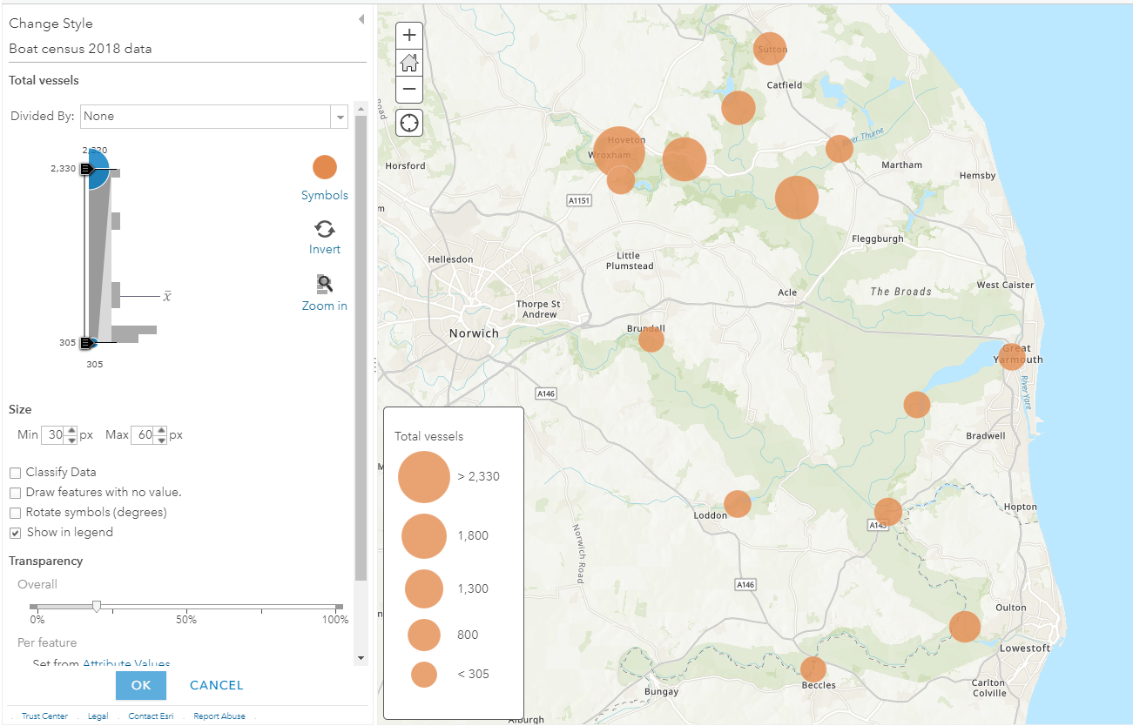
5. Printscreen some of your maps. Copy and paste these into Word for cropping. Add a title and print!
2. Open arcgis.com - click on word ‘map’ on top of page
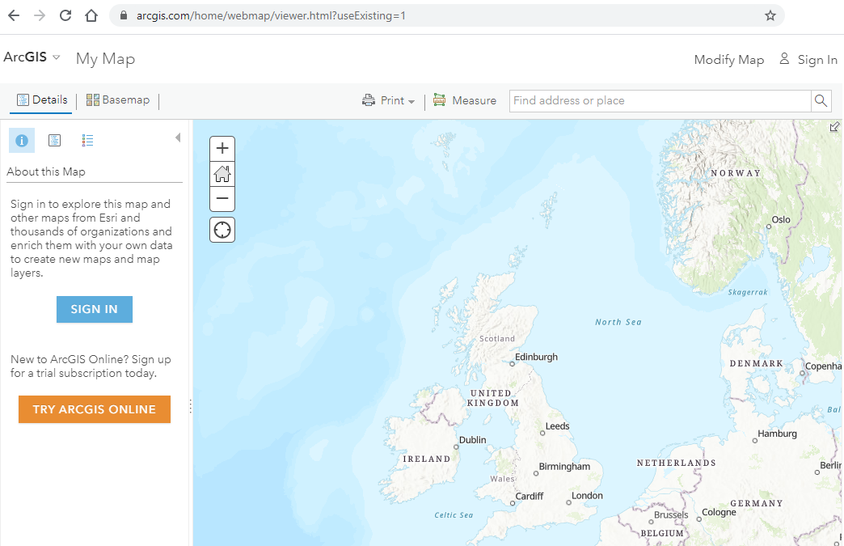

- Make Excel file of above data – save in csv format
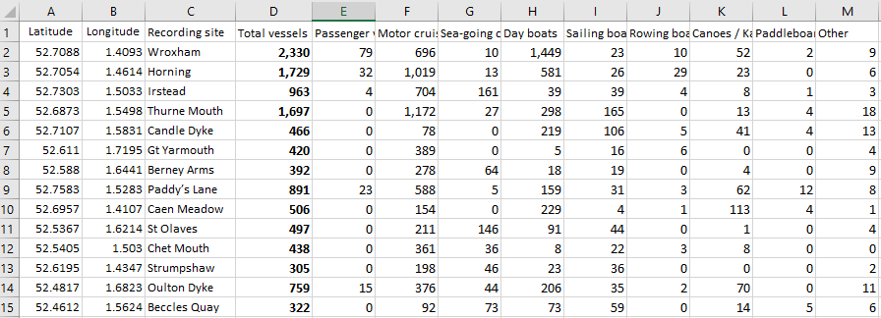
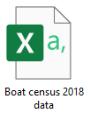

3. Drag your Excel file onto the map of the UK

Task: Complete steps 1-5 above picking any map you like. Create a word document with a title to describe what your map is showing. Leave space under your map to describe what it shows. You could use 4 boxes to cover: Most popular location, least popular location, overall trend / pattern of your results and finally, consider how these results compare to the other vessel groups.
Mapping boat data in the Broads using GIS
Paddleboarding
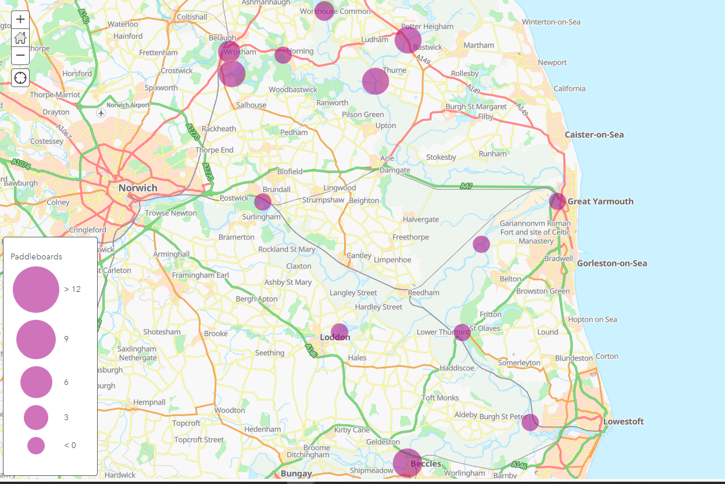

Analysis of results:
Tip: Use sentences with specific data and place names in your analysis.
Most popular location (highest) | Least popular location (lowest)
Overall trend / pattern | Comparison to other results

