Fieldwork in the Broads

Aim: What age group does the Broads currently appeal to most?

Why are we asking this question? The Broads has traditionally been popular with older people due to its slower pace of life and the wide range of quiet, relaxed activities which can be enjoyed there. Is this still the case? Is there a higher proportion of older people in the area than youngsters? By attempting to measure the approximate ages of people in Broads we aimed to find out.
Our fieldwork:
Method of data collection | Methodology (have we gathered our data):
Age survey | We visited 5 different areas in the Broads on 3 separate days, including a bank holiday, a Saturday and a mid-week day.  On each occasion, we completed an age survey of 20 pedestrians at each site, therefore gathering 100 results each day and 300 in total. We combined our results from all 3 days together.  We tried to discretely estimate people’s age within categories of 10 years as they walked past a chosen spot, rather than asking them directly as we didn’t consider this to be appropriate!

Our results:
0-10 | 11-20 | 21-30 | 31-40 | 41-50 | 51-60 | 61-70 | 71-80 | 81-90 | 91-100
23 | 26 | 17 | 34 | 49 | 73 | 50 | 21 | 5 | 2

Presenting our data:
Interpreting this data:

Which age group is the Broads most popular with?
……………………………………………………….
What do the results for the age groups between 0–30 year olds suggest about the Broads currently?
……………………………………………………….
……………………………………………………….
……………………………………………………….
……………………………………………………….
……………………………………………………….
Based on the results here, should the Broads Authority consider ways to make the area more appealing for younger people?
Yes / No

11-20
Fieldwork in the Broads

Aim: Which are the busiest locations within the Broads?

Why are we asking this question? There are particular parts of the Broads which are more developed, have more attractions and have more capacity to cope with higher numbers of people. However, there are other areas which are less visited, by completing a pedestrian survey across a range of locations within the Broads it is possible to establish which are the most popular and busiest parts of the park.
Our fieldwork:
Method of data collection | Methodology (have we gathered our data):
Pedestrian count | We visited 20 different locations within the Broads over a weekend. Each location was near to the water was a space open to the public such as a park, high street or riverside walkway.  At each location we completed 3 separate counts, all lasting 5 minutes and at 5-minute intervals between each survey. We later added these results to give a total for each site. We recorded people walking or running only. We didn’t count people cycling, in vehicles or on the water itself.

Our results:
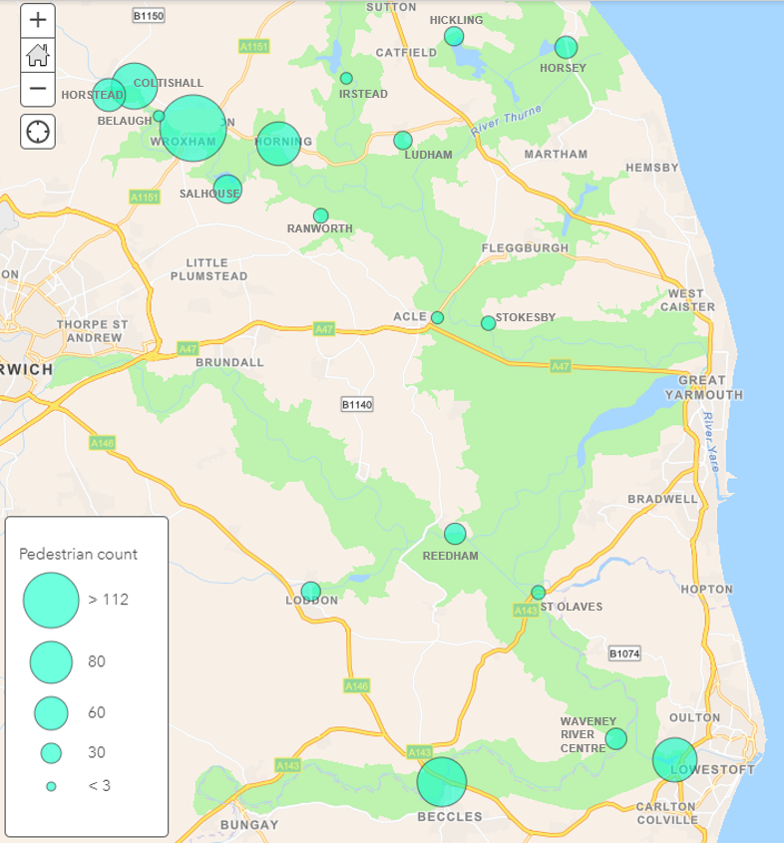
Interpreting this data:

Which location had the highest number of pedestrians?
……………………………………………………….
Give some reasons as to why this location may have a higher number of pedestrians?
……………………………………………………….
……………………………………………………….
……………………………………………………….
……………………………………………………….
……………………………………………………….
……………………………………………………….
Is there a correlation between the number of pedestrians and the distance from a major road?
Yes / No / Not sure

